PRESS RELEASE
UK Subcontractor fully exploits hyperMILL® machining strategies
Bicycle Milled From Solid Stock
Wessling (Germany), 16 November 2016 – With its mountain bike frame milled from solid stock, North Bucks Machining Ltd, based in Milton Keynes, UK, has created a new reference workpiece that demonstrates the many possibilities offered by the hyperMILL® CAM suite from OPEN MIND Technologies.
Engineer Steward Palmer introduced the hyperMILL® CAM system to his parents' family business to make more efficient use of the company's 5-axis machining centre. The extremely powerful machining strategies of the CAM software allowed him to realise his personal dream of developing his own weld-free and weight-optimised downhill mountain bike frame.
The main frame, seat post and swing arm are each milled from solid aluminium blocks. Here, Palmer took advantage of the roughing module in the hyperMILL® MAXX Machining performance package. The high-performance cutting (HPC) strategies allowed North Bucks Machining to achieve large stock removal volumes in the shortest time possible. Palmer explains: “Using hyperMILL®, we were able to machine the main frame in one hour and 30 minutes. In the past, this took two hours and 20 minutes. This is equivalent to a reduction of around 40 percent.”
An aluminium frame weighing less than 7kg was machined from raw material with a starting weight of 165kg. But this isn't enough for Palmer: He now seeks to further enhance the design of the frame to reduce the overall weight to 5kg.
Perfect Surface
The finishing strategies offered by hyperMILL® were also very important as the bike frames produced by North Bucks Machining do not undergo secondary finishing operations. It's only since calculating the toolpaths with the CAM software from OPEN MIND that the company has been able to achieve the desired surface finish.

Available images
The following images are available for download in printable format at:
http://www.htcm.de/kk/openmind
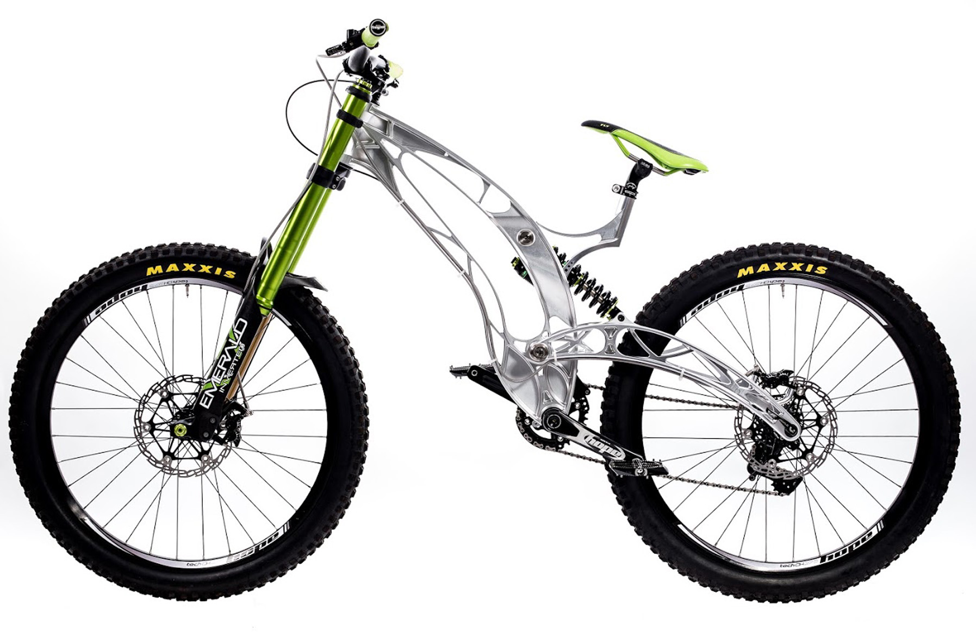Image source: North Bucks Machining  Milled from solid stock with hyperMILL®: Mountain bike from North Bucks Machining | 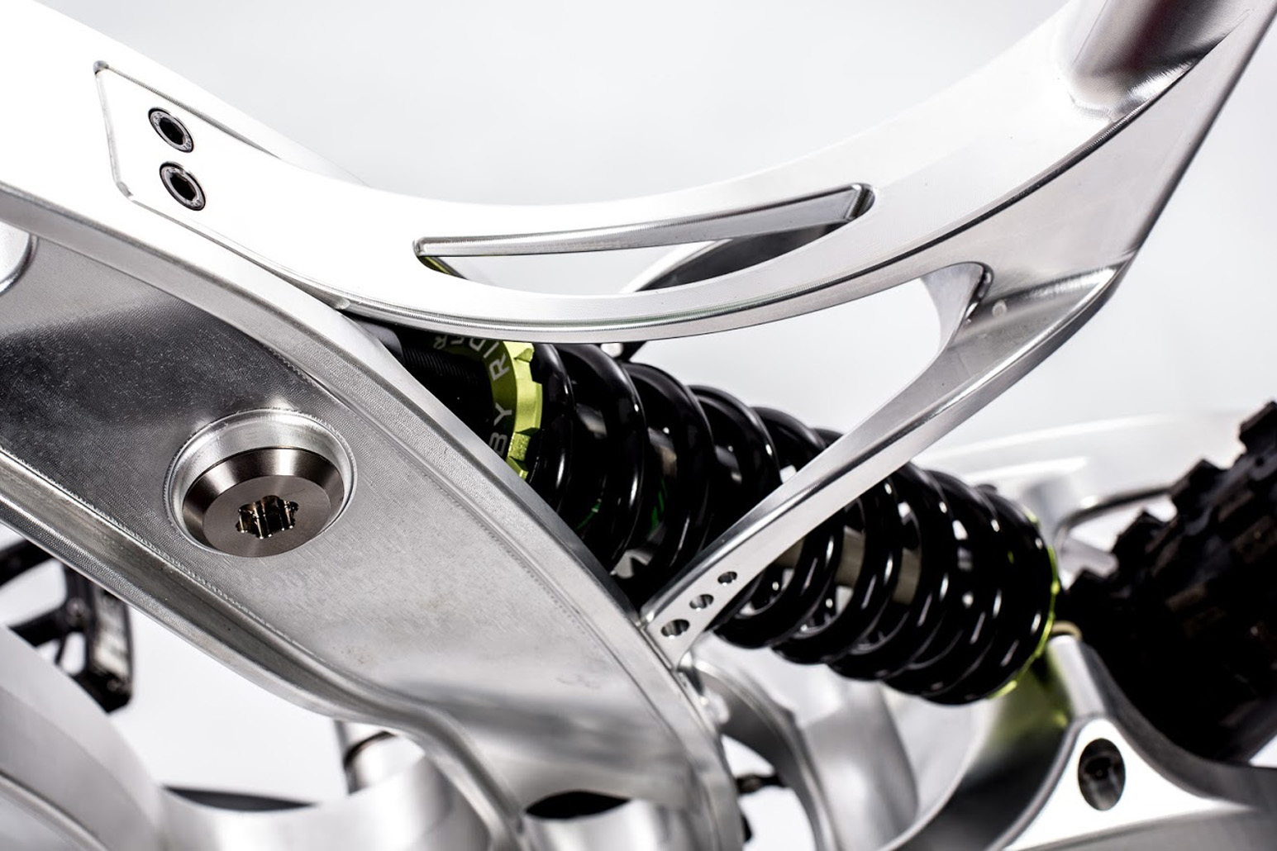Image source: North Bucks Machining  Section of the mountain bike frame

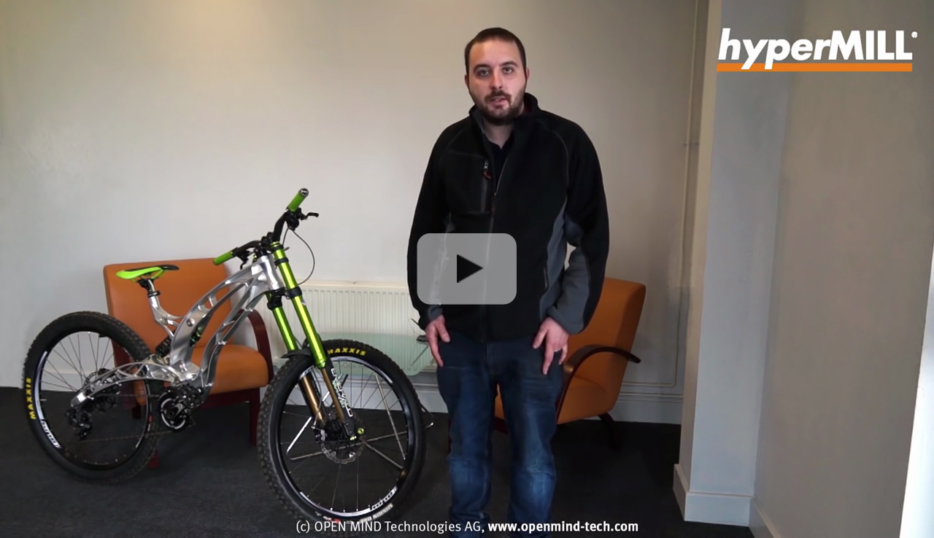

Video: hyperMILL® in action at North Bucks Machining.

About OPEN MIND Technologies AG
OPEN MIND is one of the world’s most sought-after developers of powerful CAM solutions for machine and controller-independent programming.
OPEN MIND develops optimized CAM solutions that include a high number of innovative features not available elsewhere to deliver significantly higher performance in both programming and machining. Strategies such as 2,5D, 3D as well as 5axis milling/mill turning, and machining operations like HSC and HPC are efficiently built into the hyperMILL® CAM system. hyperMILL® provides the maximum possible benefits to customers thanks to its full compatibility with all current CAD solutions and extensive programming automation.
OPEN MIND strives to be the best and most innovative CAM/CAD manufacturer in the world, helping it become one of the top five in the CAM/CAD industry according to the NC Market Analysis Report 2016 compiled by CIMdata. The CAM/CAD solutions of OPEN MIND fulfil the highest demands in the automotive, tool and mould manufacturing, production machining, medical, job shops, energy and aerospace industries. OPEN MIND is represented in all key markets in Asia, Europe and America, and is a Mensch und Maschine company.

You can find more information at www.openmind-tech.com.

OPEN MIND Technologies USA, Inc.
1492 Highland Avenue, Unit 3
Needham MA 02492
USA
Phone: +1 339 225 4557 office
Phone: +1 888 516 1232 x0 toll-free
Fax: +1 270 912 5822
E-mail: Info.Americas@openmind-tech.com

OPEN MIND Technologies UK Ltd., Oxford
Units 1 and 2
Bicester Business Park
Telford Road
Bicester
Oxfordshire OX26 4LN
England
Fon: +44 1869 290 003
Fax: +44 1869 369 429
E-mail: Info.UK@openmind-tech.com

Head office:
OPEN MIND Technologies AG, Argelsrieder Feld 5, 82234 Wessling, Germany
Tel.: (+49-8153) 933-500, Fax: (+49-8153) 933-501
E-mail: Info@openmind-tech.com, website: www.openmind-tech.com

Press contact:
HighTech communications GmbH
Brigitte Basilio
Grasserstrasse 1c
80339 Munich
Germany
Tel.: (+49-89) 500778-20
Fax: (+49-89) 500778-78
E-mail: b.basilio@htcm.de
Website: www.htcm.de

